**University of Petroleum and Energy Studies**

School of Computer Science

Department of Cybernetics

**Graphics & Animation Tools**

**LAB FILE**

**(Session: 2020-2021)**

Course: B. Tech with Specialization in Open Source and Open Standards

Submitted To- Submitted By-

Dr. Durgansh Sharma Kunal Ojha

Associate Professor SAP ID -500063333

Department of Cybernetics Roll No. -R100217034

**Experiment 2-** Design of Logo using GIMP

Step 1- Scan and import your handrawn image into GIMP.



Step 2- Arrange the images for the design you have selected.

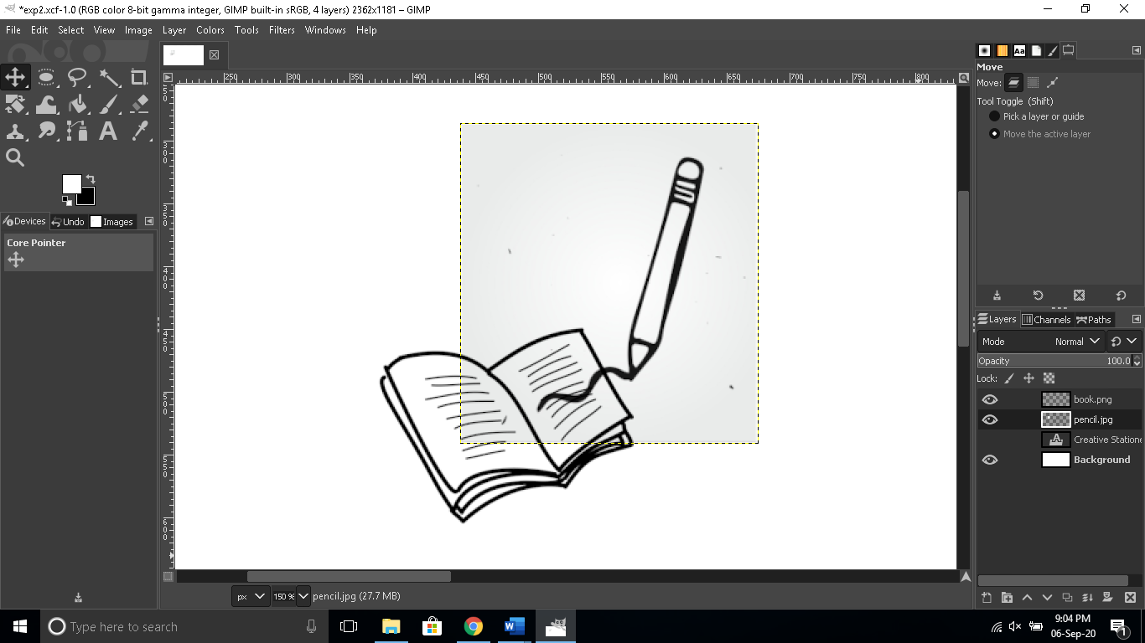

Step 3- Use the Text tool to add text if any exists in the logo design

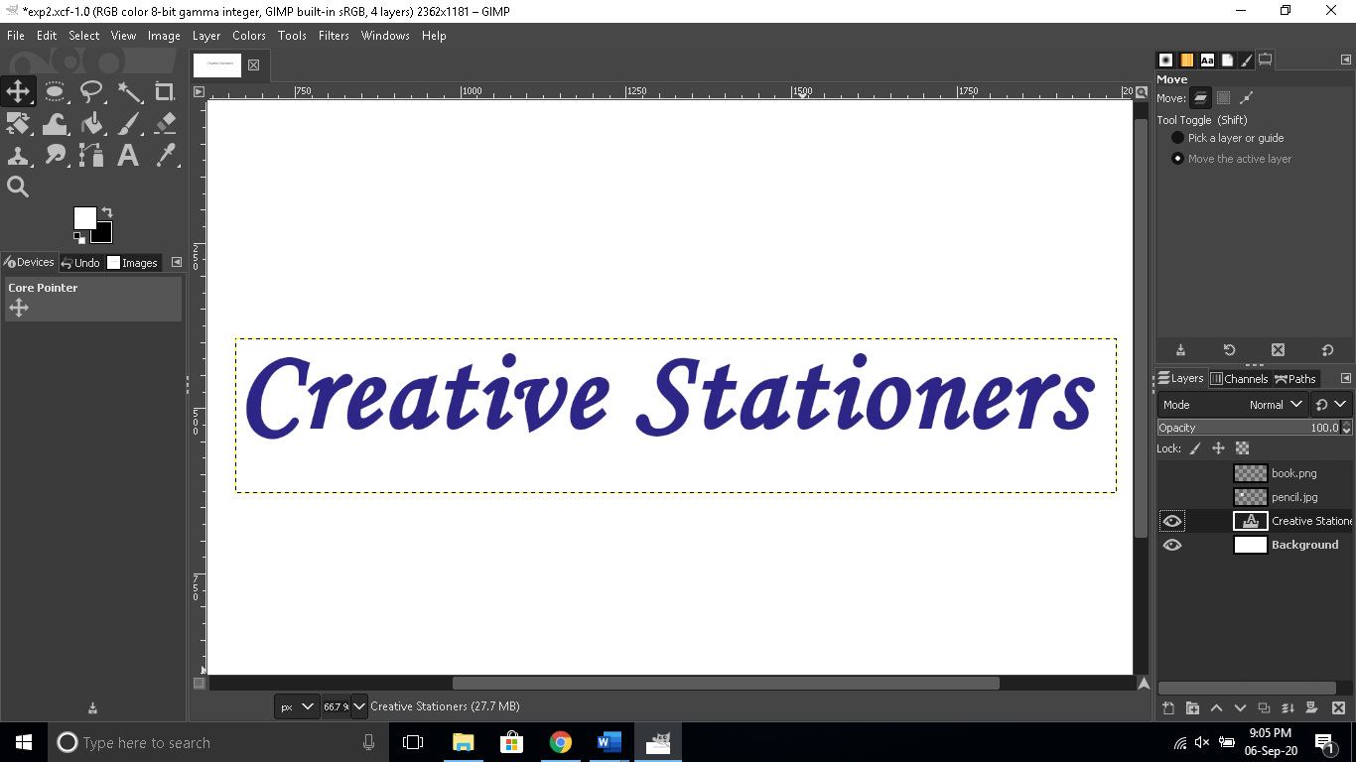

Step 4- Place the text at an appropriate position using the move tool.

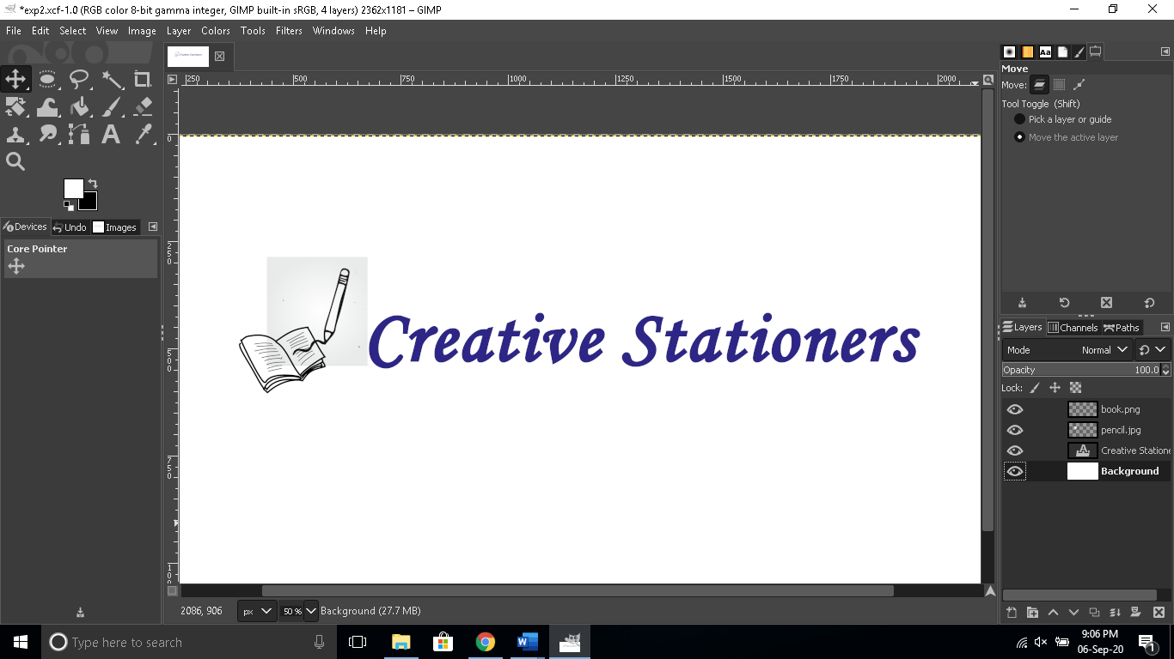

Step 5. Export the logo as a .jpeg or .png image.

